reQuestions and Answers

1.How to connect Linked Service with any Rest API’s & How to optimize and debug in case of issues like the Data is not extracted from the copy activity?

Ans:

Connecting a Linked Service to a REST API in Azure Data Factory (ADF) involves using the "Web" Linked Service. The Web Linked Service allows us to interact with RESTful APIs and perform operations like GET, POST, PUT, DELETE, etc. to extract or send data.
To create linked service:
Configure Web Linked Service:

Enter a name for the Linked Service and provide the base URL of the REST API we want to connect to. we can also configure additional settings like authentication depending on the API requirements.

Create a Dataset:
After creating the Web Linked Service, we need to define a Dataset that represents the data you want to interact with in the REST API.
Configure the Dataset with the appropriate settings, such as resource URL, format, headers, etc.
Now copy activity can used after the linked service and dataset creation.

Optimizing and Debugging Data Extraction Issues:
- Verify that you have provided the correct base URL, headers, and authentication settings in the Web Linked Service and Dataset configurations.
- Inspect API Response: Use tools like Postman or URL to directly call the REST API and check the response. Ensure that the API is returning data as expected.
- Enable Debug Logging: Turn on debug logging for your Data Factory pipeline. This will provide detailed information about the execution flow, activities, and data movement.
- Verify CORS and Firewall Rules: Ensure that the REST API allows incoming requests from the Azure Data Factory IP addresses by configuring CORS (Cross-Origin Resource Sharing) or firewall rules if required.
- Inspect API Rate Limits: Some APIs have rate limits, and excessive requests can lead to throttling. Check if the API has any rate limits and adjust the Data Factory pipeline accordingly.

2.What trigger is needed to use in ADF, when a file comes in ADLS the pipeline has to trigger. Tumbling window trigger and its use cases

Ans:

Event-Based Triggers initiate pipeline execution based on external events or triggers from external services. So when a file comes in the event will be triggered thus pipeline starts
These triggers can be configured to watch events from other Azure services, like Blob Storage events, Data Lake events, or external webhooks.

Tumbling Window Trigger:
Tumbling Window Triggers are based on time windows that move in fixed-size, non-overlapping intervals.
A pipeline is triggered at the start of each window and processes data for that time range.
Use case:
Tumbling Window Triggers are suitable for scenarios where data is partitioned based on time For Example: daily partitions, and we want to process data for each time window separately and non-overlapping of pipelines.
Tumbling windows are non-overlapping, which means that data points belong to only one specific window. Data points that fall outside the current window are not included in the current aggregation.

3. How to create mount path for adls path in Databricks?

Ans:
- Create service principal in Azure AD and get client ID and tenant ID from AD assign appropriate roles to the service principal to access ADLS account
- Generate client secret from Certificates and Secrets
- Register the secret into the key vault
- Now configure the storage account path in data bricks using dbutils.fs.mount by adding the configuration using the client id, secret and tenant id with an mount point name.
- Thus ADLS path is mounted.

4. Medallion architecture Raw, Bronze, Silver and Gold and its purpose.

Ans:

Medallion architecture are the 3 layers of the Delta lake storage where each layer as it own nature of it
First the source data is stored in the raw layer where the data from the source are stored in Parquet format or any suitable format based on source type.

Bronze Layer: Bronze has the minimally processed raw data for some cases bronze will be raw layer landing zone, either in its raw format or delta table format, nature of bronze layer is to contain all the historical data to ensure data lineage and audit purpose.

Silver Layer: Silver layer represent the curated, where the data is cleansed, bad records and deduplication of bronze data is happened and data quality checks, schema validations and data enrichment are done and stored in delta format which will be used to do final business logic transformation.

Gold Layer: Gold layer represents the final, refined, and highly curated data that is ready for consumption by business users, BI tools, and machine learning models.
Here the business logic transformations and aggregations are done and optimizations are all done for the downstream seamless consumptions. It is an single version of the truth and provides high-quality, reliable data to the end-users, promoting a consistent view of the data across the organization.

5. Why Delta over Parquet?

Ans:

Parquet format is columnar storage which allows better performance and compression to minimize storage requirements its very well suitable for big data processing especially for read operations, but it is an read-only format once the data written it cannot be modified, it requires the rewriting of the whole data, it has schema evolution.
But with Delta there more optimizations it supports ACID transactions hence allows concurrent read and writes are safely. Updates and deletes can happen efficiently, it is more suitable in handling changing data over time. Delta optimize, Z-ordering, data skipping helps in optimizing the data, Schema evolution to ensure efficient data consistency and quality over schema’s, Metadata management through delta logs enables versioning and time travel to previous versions of the data.

6.How spark job execution will be in Dataframes and Spark SQL?

Both Spark SQL and Dataframes are executed similarly both first builds a logical plan(DAG), then optimizes using catalyst optimizer, logical plan is converted into physical plan and spark process that physical plan.

Key difference: Spark SQL use sql queries and Dataframes uses dataframe API’s on Optimization part Dataframes benefit from Dataframe API specific optimizations, for programmatic approach dataframe has more flexibility and control.

7. What kind of join should be done for a large table and master table? How can it be used for Optimization.

Ans:

Broadcast Join

Optimizations: It is used to optimize the performance of join operations between a large, distributed dataset and a relatively smaller dataset by broadcasting.

The smaller dataset to all worker nodes.

In a typical join operation, data is shuffled across the network, and each worker node needs to exchange data with other nodes to perform the join.

This can be resource-intensive and time-consuming, especially when dealing with large datasets.

By using broadcast joins, we can reduce the time and resources required for join operations and improve the overall performance.

However, it's essential to carefully choose the datasets to broadcast and ensure that broadcasting doesn't lead to excessive memory consumption

on the worker nodes. Broadcasting very large datasets may cause memory pressure and affect performance rather than improve it.

Here broadcast join works like:

Join:

Each worker node performs the join operation between its local copy of the smaller dataset and the corresponding partition of the larger dataset.
Since the smaller dataset is available in memory locally on each node, the join can be executed much faster without the need for data movement.

Questions and Answers

Time Travel/ Versioning in delta table and its command?
Ans:
Time Travel:
Time Travel allows us to query and access historical snapshots of a Delta table.
Time Travel, you can access data from specific points in time, which is useful for auditing, historical analysis, and debugging. Time Travel enables you to view data as it appeared at a particular version, without affecting the current data.
Command: DESCRIBE HISTORY [table_name]
Versioning:
Versioning allows you to manage and control the different versions of data in a Delta table.
Command: CREATE OR REPLACE TABLE [table_name] [AS] (query) VERSION AS [version_num]
Vacuum in Delta table and its command?
Ans:
Vacuum removes the file no longer referenced by a delta table
We can remove file no longer referenced by a delta table and are older than the retention threshold by running the vacuum command on the table.
Vacuum is not triggered automatically. Vacuum deletes only data files, not log files.
The default retention period of log file is 30 days.
Command: VACUUM [table_name] [RETAIN num_hrs]
How to Mount data lake container to databricks?
Ans:
To mount an Azure Data Lake Storage container to Azure Databricks, following steps:
- Create app registration.
- Give storage BLOB data contributor access to app registration in IAM.
- Generate secret from app registration.
- Create a key vault.
- Save secret in key vault.
- Create scope in databricks

How to Optimize the spark code?
Ans:
Optimizing Spark code that improve query performance and reduce execution time.
- Data is properly partitioned based on the columns used in your queries. This allows Spark to parallelize the processing efficiently. For that use repartition() or coalesce() functions to control the number of partitions.
- For small DataFrames, use broadcast joins to avoid shuffling the entire data across the network.
- Select only the required columns in your queries instead of reading all columns from the data source.
- Cache frequently accessed DataFrames.
- Store your data in the Parquet format, as it provides efficient compression and columnar storage, leading to faster data access.
- Tune Spark memory configurations based on your cluster and workload requirements.
What are the different types of internal joins ?
Ans:
In Apache Spark, there are three main internal join types that are used to combine data from multiple DataFrames or datasets:
- Shuffle hash join
- Broadcast hash join
- Sort merge join.

Shuffle Hash Join:
Shuffle hash join is used when joining large datasets that cannot fit in memory. It involves a two-step process:
Partitioning: Both DataFrames are partitioned using a hash function based on the join key.
Shuffling:The partitions with the same hash value from both DataFrames are shuffled and co-located on the same executor nodes.
Shuffle hash join is an expensive operation, especially for large datasets, as it requires significant data movement across the network.
Broadcast Hash Join: Broadcast hash join is used when one Data Frame is small enough to fit in memory. The smaller Data Frame is broadcasted to all worker nodes, and the join is performed locally on each worker node without the need for data shuffling.
Sort Merge Join:
Sort merge join is used when joining large datasets that are sorted on the join key. It involves a two-step process:
Sorting: Both DataFrames are sorted based on the join key.
Merging: The sorted DataFrames are merged, and the matching records are combined to produce the final result.
Sort merge join is more efficient than shuffle hash join for large datasets when the data is already sorted on the join key. However, it requires prior sorting, which can be expensive, especially if the data is not naturally sorted.

Explain transformation in spark?
Transformations are applied to a Spark DataFrame or RDD to process the data. Transformations are lazy operations; they are not executed immediately its build a lineage of transformations.
Transformation is performed when an action is called on the DataFrame or RDD.
Some common transformations are:
1. Map 2. Filter 3. GroupBy
4. SortBy 5.Distinct 6.Join
7.Union 8.Select 9.WithColumn.
10.Drop
SQL Query
write sql query to get daywise highest sell from tables
SELECT s.sale_date, p.product_name, MAX(s.quantity_sold) AS highest_sell
FROM sales s
JOIN product p
ON s.product_id = p.product_id
GROUP BY s.sale_date, p.product_name
Project architecture and Questions around on our project related to incremental load

Spark and Databricks

1.Describe the Architecture of Spark job execution. (Driver, Executor, Job, Task)
Ans:
Spark Job Submits the command to the driver program, Driver Program is the entry point of the Spark application. It runs on the Driver node and coordinates the overall execution of the Spark job. It splits the application into tasks and schedules them on worker nodes. Worker nodes executes the task assigned by the Driver node, these resources are managed by Cluster Managers, the spark job that has been submitted represented as Stages and task in DAG visualizer logically split.
Stage is set of transformation operation until an shuffling action is called. When a shuffling is needed spark marks the end of the current stage and starts an new stage.
Tasks are the inner transformation within the stage based on each partitions it is having, so transformation on number of partition will be number of tasks in a stage.
In the background even if we have dataframes all the transformation tasks are splited on RDD level
2. What is data shuffling?
Ans:
Data shuffling is the distribution of data across all partitions during any operations which involves data movement across different nodes which is expensive due to movement of data can impact performance and increase memory overhead, hence minimize shuffling is an optimized way to increase spark performance.
Eg: group By, join will lead to data shuffling.
3. What is difference between Wide and Narrow transformations?
Ans:
Narrow transformation:
Narrow transformation do not have any data shuffling these transformations and done in the same partitions with no data movement across partitions or nodes
Eg: map, filter, union
Wide transformation:
Wide transformation have Data shuffling across partitions or nodes
Eg: Joins, aggregations, groupBy.
4. How can you read data from different sources (e.g., CSV, Parquet, JSON) in Databricks using Spark?
Ans:
Each datasource files can be read with spark.read
For csv spark.read.csv(“path”) or spark.read.format(“csv”).load(“load”)
Parquet spark.read.parquet(“path”)or spark.read.format(“parquet”).load(“load”)
Json spark.read.json(“path”)or spark.read.format(“json”).load(“load”)
5. Explain the concept of lazy evaluation in Spark. How does it help with optimizing data processing?
Ans:
Lazy evaluation, a distributed data processing engine. Instead of immediately performing transformations on the data,
Spark builds a logical execution plan using DAG to represent the sequence of transformations. It is not performed until we trigger the actions.
Lazy evaluation helps with optimizing data processing in several ways:
Minimizing Data Movement:
By delaying the execution of transformations until an action is triggered, Spark can optimize the execution plan based on the lineage graph.
Reducing Overhead:
Since transformations are not immediately executed, there is no need to allocate memory for intermediate results until its required.
Caching Control:
With lazy evaluation, Spark can make informed decisions about what data to cache in memory.
6. What are transformations and actions in Spark? Provide examples of each?
Ans:
Transformations:
When we apply transformations to a Spark RDD or DataFrame, Spark does not immediately execute them.
Firstly, it creates a lineage graph that represents the sequence of transformations.
Examples are:
Map, Filter, Group by, Join
Actions:
Actions trigger the execution of the transformations and produce a result. When an action is invoked,
Spark uses the lineage graph to compute only the data needed to produce the output.

Examples are:
Collect, Count, save, Foreach

6. Describe the process of caching data in Spark. When would you use caching?
Ans:
Caching data in Spark refers to the process of storing the contents of an RDD or DataFrame in memory or on disk to avoid recomputing the data.
when it is needed again. Caching can significantly improve the performance of iterative algorithms or when multiple actions depend on the same dataset.
as it allows Spark to reuse the computed data without recalculating it from the original source.
It provide Two level of catching:
MEMORY_ONLY:
The data is stored in memory. This provides the fastest access but may consume a large amount of memory.
MEMORY_AND_DISK:
The data is stored in memory, but if the data does not fit in memory, it will spill to disk.
This level of caching provides a good balance between performance and memory usage.
We use catching when:
- Iterative Algorithms:
- Reusing Data:
- Narrow Transformations:
7. What is a broadcast join? How can it be used for Optimization?
Ans:
It is used to optimize the performance of join operations between a large, distributed dataset and a relatively smaller dataset by broadcasting.
The smaller dataset to all worker nodes.
In a typical join operation, data is shuffled across the network, and each worker node needs to exchange data with other nodes to perform the join.
This can be resource-intensive and time-consuming, especially when dealing with large datasets.

By using broadcast joins, we can reduce the time and resources required for join operations and improve the overall performance.
However, it's essential to carefully choose the datasets to broadcast and ensure that broadcasting doesn't lead to excessive memory consumption
on the worker nodes. Broadcasting very large datasets may cause memory pressure and affect performance rather than improve it.
Here broadcast join works like:
Join:
Each worker node performs the join operation between its local copy of the smaller dataset and the corresponding partition of the larger dataset.
Since the smaller dataset is available in memory locally on each node, the join can be executed much faster without the need for data movement.
Broadcast join provides optimization:
-One of the datasets is significantly smaller than the other.
-The smaller dataset can fit comfortably into the memory of each worker node.
-The join operation is a common operation in the workflow, and the same smaller dataset is used in multiple join operations.
8. What are the different types of joins in Spark and how do they work internally?
Ans:
In Apache Spark, there are three main internal join types that are used to combine data from multiple DataFrames or datasets:
- Shuffle hash join
- Broadcast hash join
- Sort merge join.

Shuffle Hash Join:
Shuffle hash join is used when joining large datasets that cannot fit in memory. It involves a two-step process:
Partitioning: Both DataFrames are partitioned using a hash function based on the join key.
Shuffling:The partitions with the same hash value from both DataFrames are shuffled and co-located on the same executor nodes.
Shuffle hash join is an expensive operation, especially for large datasets, as it requires significant data movement across the network.
Broadcast Hash Join: Broadcast hash join is used when one DataFrame is small enough to fit in memory. The smaller DataFrame is broadcasted to all worker nodes, and the join is performed locally on each worker node without the need for data shuffling.
Sort Merge Join:
Sort merge join is used when joining large datasets that are sorted on the join key. It involves a two-step process:
Sorting: Both DataFrames are sorted based on the join key.
Merging: The sorted DataFrames are merged, and the matching records are combined to produce the final result.
Sort merge join is more efficient than shuffle hash join for large datasets when the data is already sorted on the join key. However, it requires prior sorting, which can be expensive, especially if the data is not naturally sorted.
Spark's query optimizer automatically chooses the most suitable join type based on the dataset sizes, available memory, and other execution parameters. In some cases, the optimizer may apply a hybrid approach, combining different join types in a single query to optimize performance.
9. How a job is split into stages and tasks?
Ans:
A stage is a sequence of transformations on data that can be executed without data shuffling, also known as a narrow transformation.
Each stage typically corresponds to a sequence of narrow transformations.
Wide transformation, which requires data shuffling, is encountered in the execution plan, it marks the end of the current stage and the beginning of a new stage. The data shuffling operation occurs between these stages.
Tasks are the inner transformation within the stage based on each partitions it is having, so transformation on number of partition will be number of tasks in a stage.
Task is the smallest unit of work in Spark and corresponds to a single operation on a partition of data.
Independently each task is getting executed on each partition thereby achieving parallelism, also depends on number of partitions and worker nodes in the cluster
10. What are Out of Memory exceptions? How can they be removed?
Ans:
In Out of Memory exceptions happen when the cluster resources are insufficient to handle the data operations performed by Spark Jobs, resulting in memory exhaustion.

To remove the OOM exception:
- Increase the executor memory allocation.
- Scaling up the cluster configuration
- Optimizing the code, by reducing the data shuffling performing the optimized joins with broadcast or sort-merge based on table size.
- Partitioning the data across the nodes and performing operations on partitioned data, repartitioning of data to reduce data skewness.
- Cache and persist on reusing dataframes to reduce redundant computations.
- Indexing based on column.
- Optimize and Z-order in case of delta tables.
11. What is data skewness ? How will you handle data skewness?
Ans:
Data skewness is an uneven distribution of data across partitions, this impacts spark performance since tasks on skewed data takes longer to complete.
To handle it we have partition evenly using repartition or partitionBy in spark, Caching and broadcasting, filtering data before performing heavy transformation.
12. What is Delta Table ? What are various optimizations in Delta ?
Ans:
Delta table is an open source storage format build on top of the parquet
It provides ACID transaction and data versioning of data lakes.
It has several advantages and optimizations that other formats like parquet.
ACID transactions, Time Travel or versioning of the data in delta logs, delta optimize to clear small file problems, Z-order, Data skipping, Metadata management in delta transaction logs, provider Schema Evolution to ensure data quality and adding or deleting columns without affect the table schema.

Azure and ADF

1.What is Integration Runtime and difference between each type ?
Ans:
Integration Runtime did the data movement and data transformation between different data stores and services in Azure Data Factory.
It acts as a bridge between Azure Data Factory and the data sources or destinations that need to be connected.
There are three types of Integration Runtime in Azure Data Factory:
Azure Integration Runtime (Auto-Resolve):
This type of Integration Runtime is automatically created and managed by Azure Data Factory.
It automatically resolves the location of the data store and executes activities within the Azure network where the Data Factory is located.
Azure Integration Runtime (Self-Hosted):
Azure Integration Runtime (Self-Hosted) is a self-hosted version of Integration Runtime. It is installed on premises or in a virtual network managed by we or the data integration developer or administrator.
Azure Integration Runtime (Self-Hosted) establishes connectivity between the on-premises data sources and Azure Data Factory securely. Basically, it makes the connection between local system to cloud.
Azure-SSIS Integration Runtime:
Azure-SSIS Integration Runtime is a specialized type of Integration Runtime designed specifically for running SQL Server Integration Services (SSIS) packages in Azure Data Factory.
Azure-SSIS Integration Runtime can scale up or down based on the package's resource requirements,and it integrates with other Azure services for data movement and orchestration.

2. What are linked services in ADF?
Ans:
In Azure Data Factory, a Linked Service is help to represents a connection to an external data source.
The connection properties needed to establish communication between ADF and the external data store or service.
Linked Services encapsulate the connection information, credentials, and other details required to interact with the data sources or destinations involved in data movement or data transformation activities within ADF pipelines.

Linked Services are used in various ADF components, such as pipelines, datasets, and data flows, to establish connectivity with external data sources.
3. What is a service principle in ADF?
Ans:
In Azure Data Factory, a service principal is a security identity that represents an application or service
when it interacts with Azure resources.
When you create a service principal for Azure Data Factory, it provides a way for ADF to authenticate itself with other Azure services or data stores securely. Service principals are used in various scenarios within ADF, such as connecting to data sources, accessing Key Vaults for storing sensitive data, and executing activities in data pipelines.
4. What is Copy Data Activity and its optimization options in ADF?
Ans:
Copy Data Activity is one of the important activities in Azure Data Factory used for copying data between different data stores.
It enables you to move data from a source to a destination with built-in fault-tolerance, scalability, and monitoring capabilities.
Copy Data Activity supports various data sources and destinations, both in the cloud and on-premises.
Optimization Options in Copy Data Activity:
- Parallel Copies
- Preserve Order of Files
- Compression and Encryption
- Binary Copy
- Staging
- PolyBase Integration
- Performance Optimizations in Mapping

5. How do you link a Storage Account to Databricks Notebook?
Ans:
Mounting the storage account to the data bricks in mount point
Getting the Shared Access Signature Token, from AD creating or adding user to service principal getting the tenant_id, client_id and client_secret for the storage account and configuring it in the databricks as secret scope, creating the mount point with dbutils.fs.mount and access the storage account.
Getting the storage access key from Azure AD and connecting the storage credentials directly to access privately and reading them through filepath.
6. What is Key Vault? What is Scope?
Ans:
KeyVault storesnand manages the keys, secrets and certificates used in the Azure cloud service, it highly secured to store the passwords, connection strings, encryption keys and they can be accessed only with authorization and with keyvault names only, there by securing the values.
In keyvault scope is a logical container that represents a boundary for accessing and managing secrets. It helps to control access to secret, there are two scopes.
Vault Scope: Represents entire key vault, where secrets directly created in the key vault without specific secret scope, Vault Scope secrets are directly accessible by any principal (users, applications, services) with appropriate access permissions to the Key Vault.
Secret Scope: Is a logical container within the Key Vault that provides additional isolation for secrets, a subfolder within the Key Vault. A Secret Scope can have its access control list (ACL) to manage who can access the secrets within that scope. Using this we can further restrict access specific to secrets within key vault.
7. How do you export Data From Azure Databricks to Azure Synapse?
Ans:
Method 1
Export from Databricks to Azure Synapse can be done in multiple ways, having an ADLS account commonly linked to databricks and the synapse throught the copy activity.
Writing the data prepared in the Databricks to the ADLS account as an parquet file.
Using the copy activity in ADF we can copy the parquet file in adls to Azure Synapse as table.
Method 2:
We can configure the Azure Synapse connection and write the files to the Azure synapse using the connection strings in the databricks
Method 3:
Alternatively, we can use the PolyBase feature in Synapse Analytics to load data from external data sources, including Databricks Delta tables. PolyBase allows you to transfer large volumes of data efficiently between Databricks and Synapse Analytics.
Create a staging folder in Azure Storage ADLS, synapse polybase feature will leverage the staging folder to transfer data between databricks and synapse
Configuring Synapse connection as JDBC source.
Export data from databricks to synapse using Databricks notebook by the following query.
CREATE OR REPLACE synapse.target_table AS SELECT * FROM source_table.
This will also results in exporting data from databricks to synapse.
8. What are triggers ? Different types of triggers and their usecases?
Ans:
In Azure Data Factory, triggers are objects that enable you to schedule and orchestrate the execution of pipelines or other activities. Triggers are used to automate data integration workflows by initiating the execution of pipelines based on specific time intervals, events, or external conditions.
Different types of triggers:
1. Schedule Trigger:
- A Schedule Trigger is mostly used in ADF.
- It allows us to schedule the execution of a pipeline at specific time intervals for example: Daily, hourly, weekly, etc.
Use Cases:
Schedule Triggers are used for regular data movement or ETL processes that need to run on a predefined schedule, like daily data loads, hourly aggregations, or weekly backups.

2. Tumbling Window Trigger:
- Tumbling Window Triggers are based on time windows that move in fixed-size, non-overlapping intervals.
- A pipeline is triggered at the start of each window and processes data for that time range.
Use Cases:
Tumbling Window Triggers are suitable for scenarios where data is partitioned based on time For Example: daily partitions, and we want to process data for each time window separately.

3. Event-Based Trigger:
- Event-Based Triggers initiate pipeline execution based on external events or triggers from external services.
- These triggers can be configured to watch events from other Azure services, like Blob Storage events, Data Lake events, or external webhooks.
Use Cases:
Event-Based Triggers are used when you want to start a pipeline automatically in response to an event, such as the arrival of new data in a storage account.
9. How can you use parameterization to create dynamic pipelines that handle changing source or destination locations in ADF?
Ans:
Parameterization in Azure Data Factory allows you to create dynamic pipelines that can handle changing source or destination locations based on input parameters. With parameterization, we can make our pipelines flexible and reusable by externalizing settings and configurations that may vary between pipeline runs.
Here's how we can use parameterization to create dynamic pipelines in ADF:

- Define Parameter:
Parameters can be defined at the pipeline level, activity level, or dataset level.
- Reference Parameters:
Once you have defined the parameters, you can reference them within our pipeline activities, datasets, and linked services.
- Pass Parameter Values:
When triggering the pipeline, we can pass different parameter values based on our requirement. we can pass parameter values using the ADF UI, PowerShell, or the REST API.
- Use Dynamic Values in Activities:
Inside our pipeline activities, we can use the parameter values to generate dynamic expressions or construct paths for data movement.
10. What tools and features are available for monitoring and managing the execution of pipelines and activities in Azure Data Factory?
Ans.
Some important tools and features are available for monitoring and managing the execution of pipelines and activities in Azure Data Factory are:
1. ADF Monitoring UI:
- Azure Data Factory has a built-in monitoring dashboard accessible from the Azure portal. The monitoring UI provides real-time insights into the status of pipelines, activities, and trigger runs. We can view the overall health of our data factory.
2. Activity Runs:
- The Activity Runs view in the monitoring UI gives us detailed information about the start time, end time, duration, and status of each activity run, which helps in debugging and troubleshooting.
3. Trigger Runs:
- The Trigger Runs view shows the execution history of pipeline triggers.
4. Monitoring Views and Metrics:
- ADF provides various monitoring views, including trigger runs, pipeline runs, and activity runs, which give us a comprehensive overview of the data factory's performance.
- we can also access metrics such as data movement, data flow activity, and integration runtime metrics to monitor resource utilization and performance.
5. Pipeline Annotations:
- Pipeline Annotations allow us to add custom annotations and descriptions to pipelines, activities, and datasets.
6. Alerts and Notifications:
- ADF integrates with Azure Monitor, which allows us to set up alerts based on specific conditions or metrics. we can configure alerts to notify when pipeline or activity failures occur or when certain performance started.
7. ADF PowerShell and CLI:
- ADF offers PowerShell cmdlets and Command-Line Interface (CLI) commands to manage and monitor data factory resources programmatically. These tools allow you to automate administrative tasks and monitoring workflows.

Python question
Array = [1,1,1,5,5,5,2,2]
Find number of occurrences of each element (eg 1 – 3)
Sub question – what complexity of solution is and how to optimise it

SQL question
Mid Aid
M1 A1
M1 A2
M1 A3
M2 A1
M2 A2
M3 A3
M3 A4
M3 A5
Select Mid having Aids A1 and A2 only

Different types of triggers in ADF and use case of each type of trigger
What is use of optimize statement in Delta table?
Difference between delta and parquet?
What are different types of distribution methods for Synapse tables and use case of each
2-3 scenario-based questions on how to choose table distribution

2 pyspark coding questions (Expectation is not exactly code but approach to solve problem)

PepsiCo Interview by Sathya and Lakshmi – Data Engineer (October 27th, 2022)
- Tell me about yourself. Describe your most recent project.
- How is your proficiency in PySpark and Data Engineering platforms?
- What are the limitations of Delta Live Tables?
- What are the formats of data have you worked with? Describe the advantages and disadvantages of using them.
- What is coalesce?
- What is RDD?
- What are shuffles?
- Have you set up an API for querying?
- Have you worked with machine learning? Describe an instance when you have used machine learning and what is the functional significance of using that model?
- Explain how distributed computing will happen at each line of code.: there will be one shuffling for join (dept id), one for group by and then merge (dept name)?
What happens in spark - plan when get executed when ?
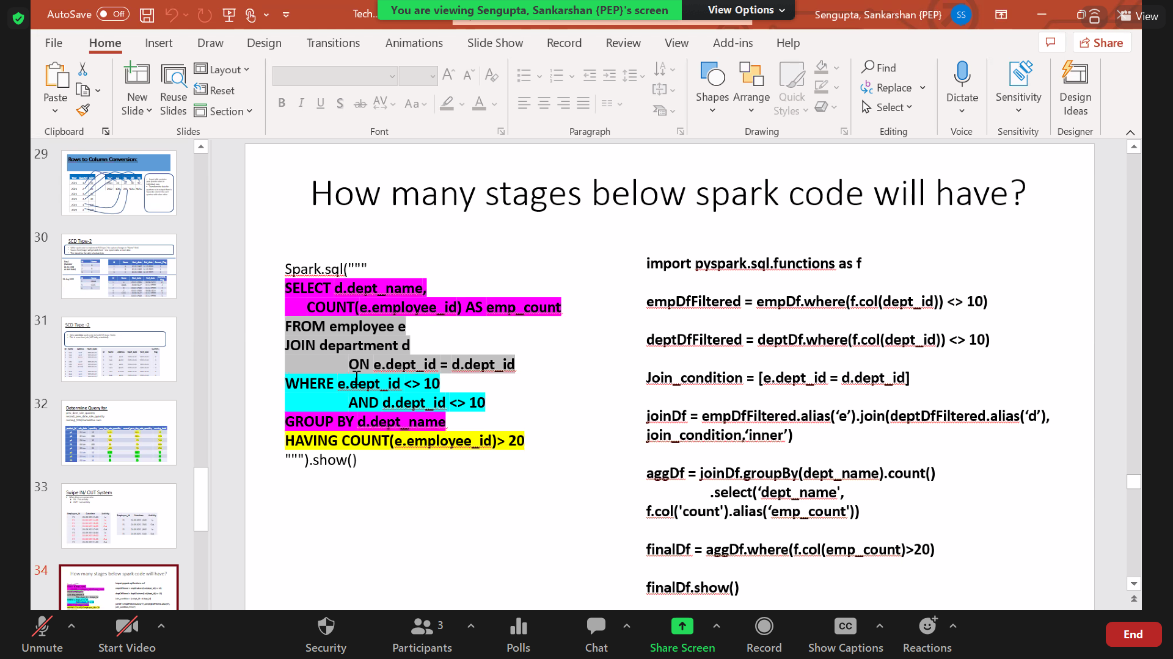
- What is broadcast and when is it useful and when its not good from performance standpoint.
Sends copy of data to every executor and avoids shuffling – if data size is smaller, it can be used; Shuffling is costly
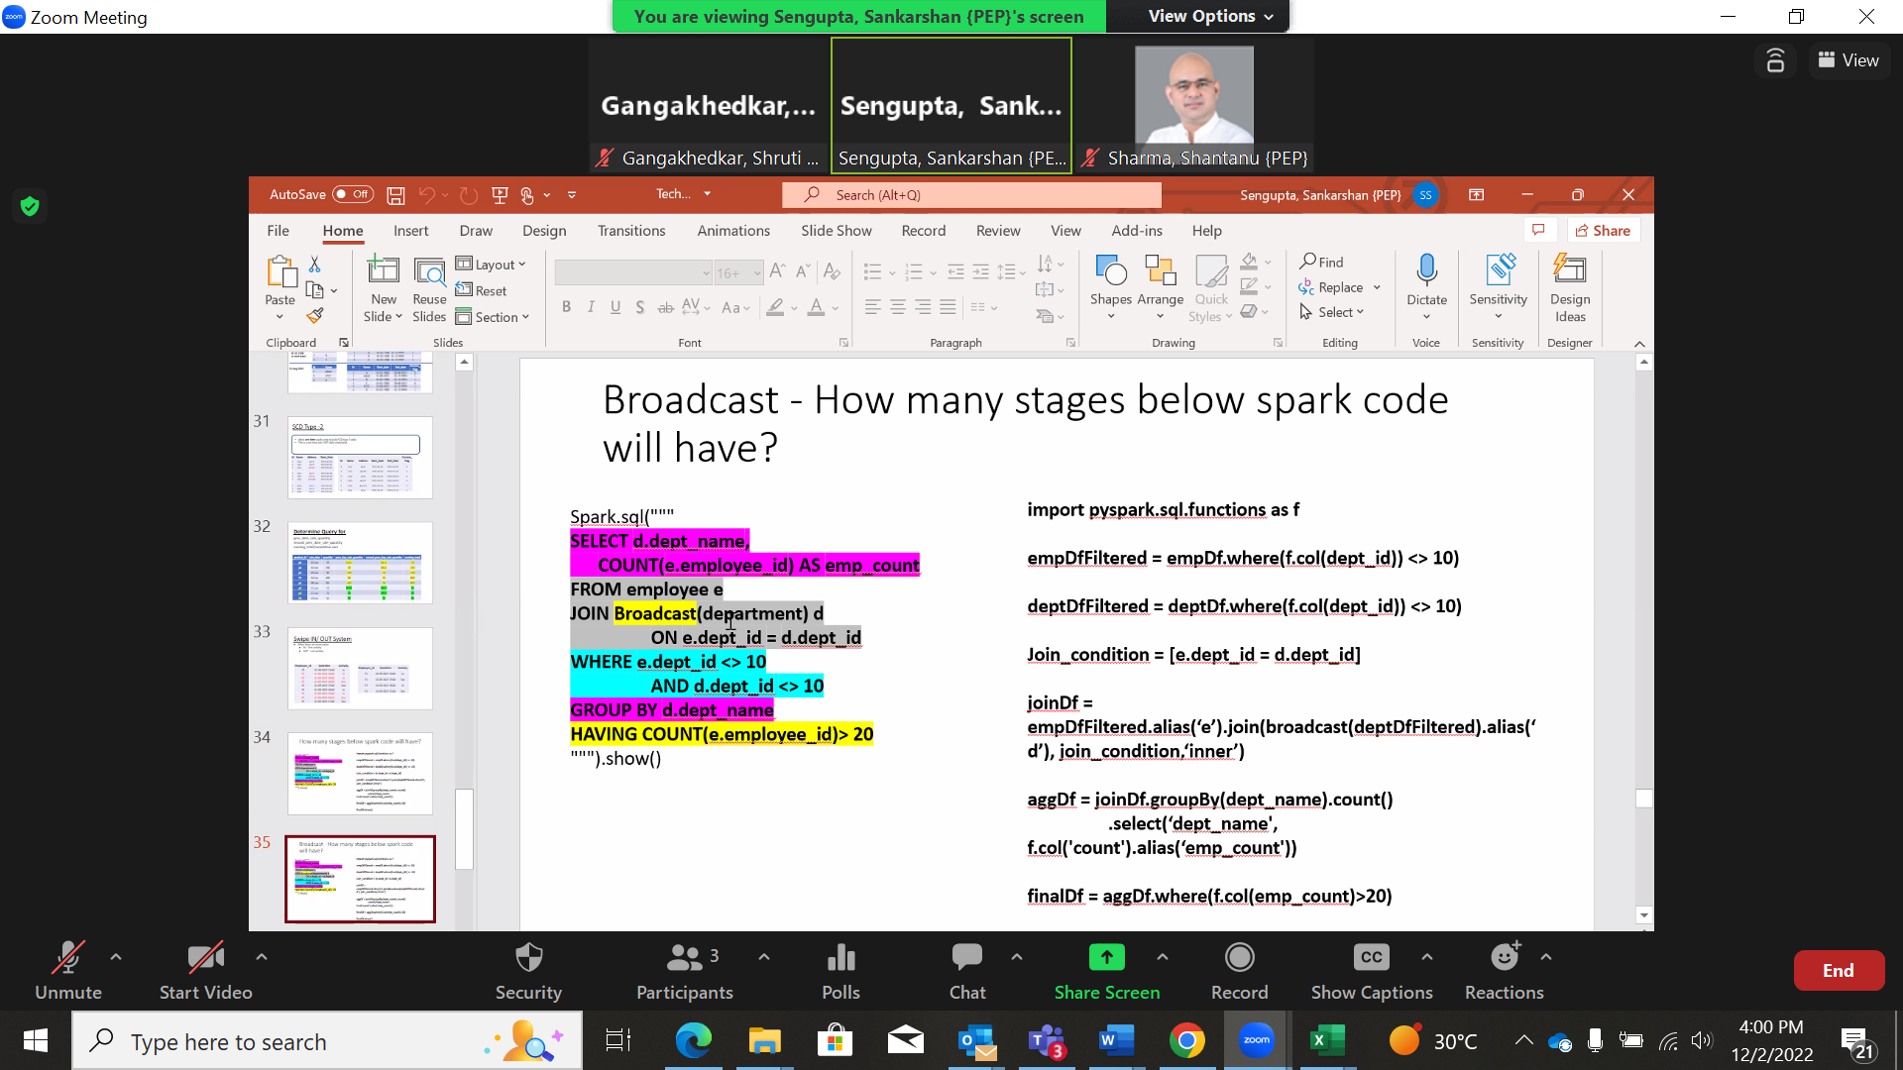
- Can we set the threshold of broadcast Spark 3.0; what happens if it’s set to -1 or Zero
- How will you optimize join between two big tables? – sort-merge shuffle join
- What is the cluster size you have for databricks? Which configuration you are using worker machine (v13 vs V16)? Considering this how do you define partitions for these tables – what strategy do you use?
- As many partitions as I can without impacting any shuffles or operations?
- Filter operation does not require shuffling. What will you do at the end of the job to reduce small file problem? What does Z Order does and Optimize does?
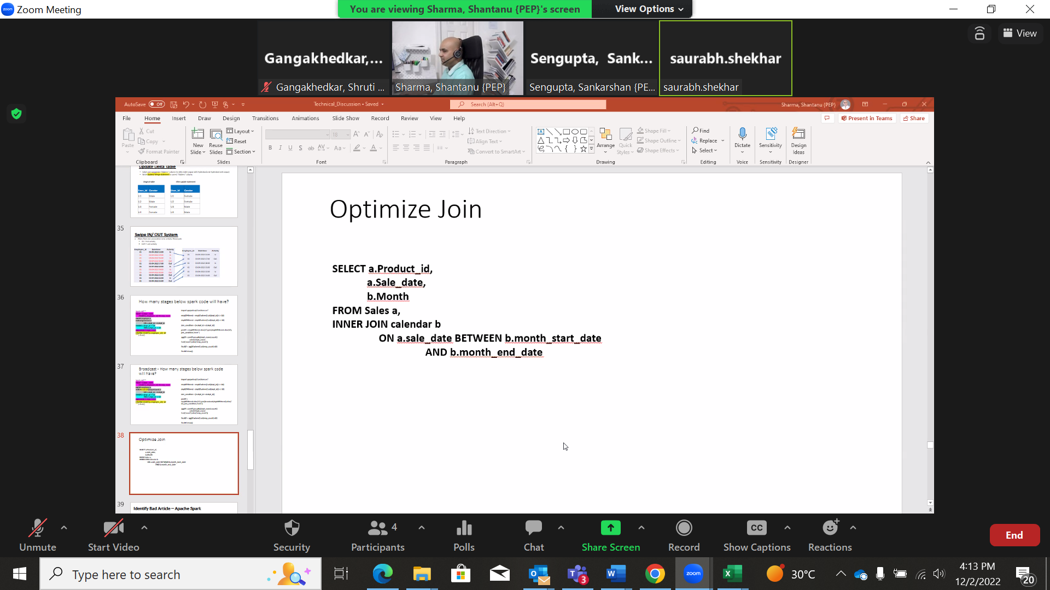

- Why would you sort the columns?
- What function will you use? Rankover?
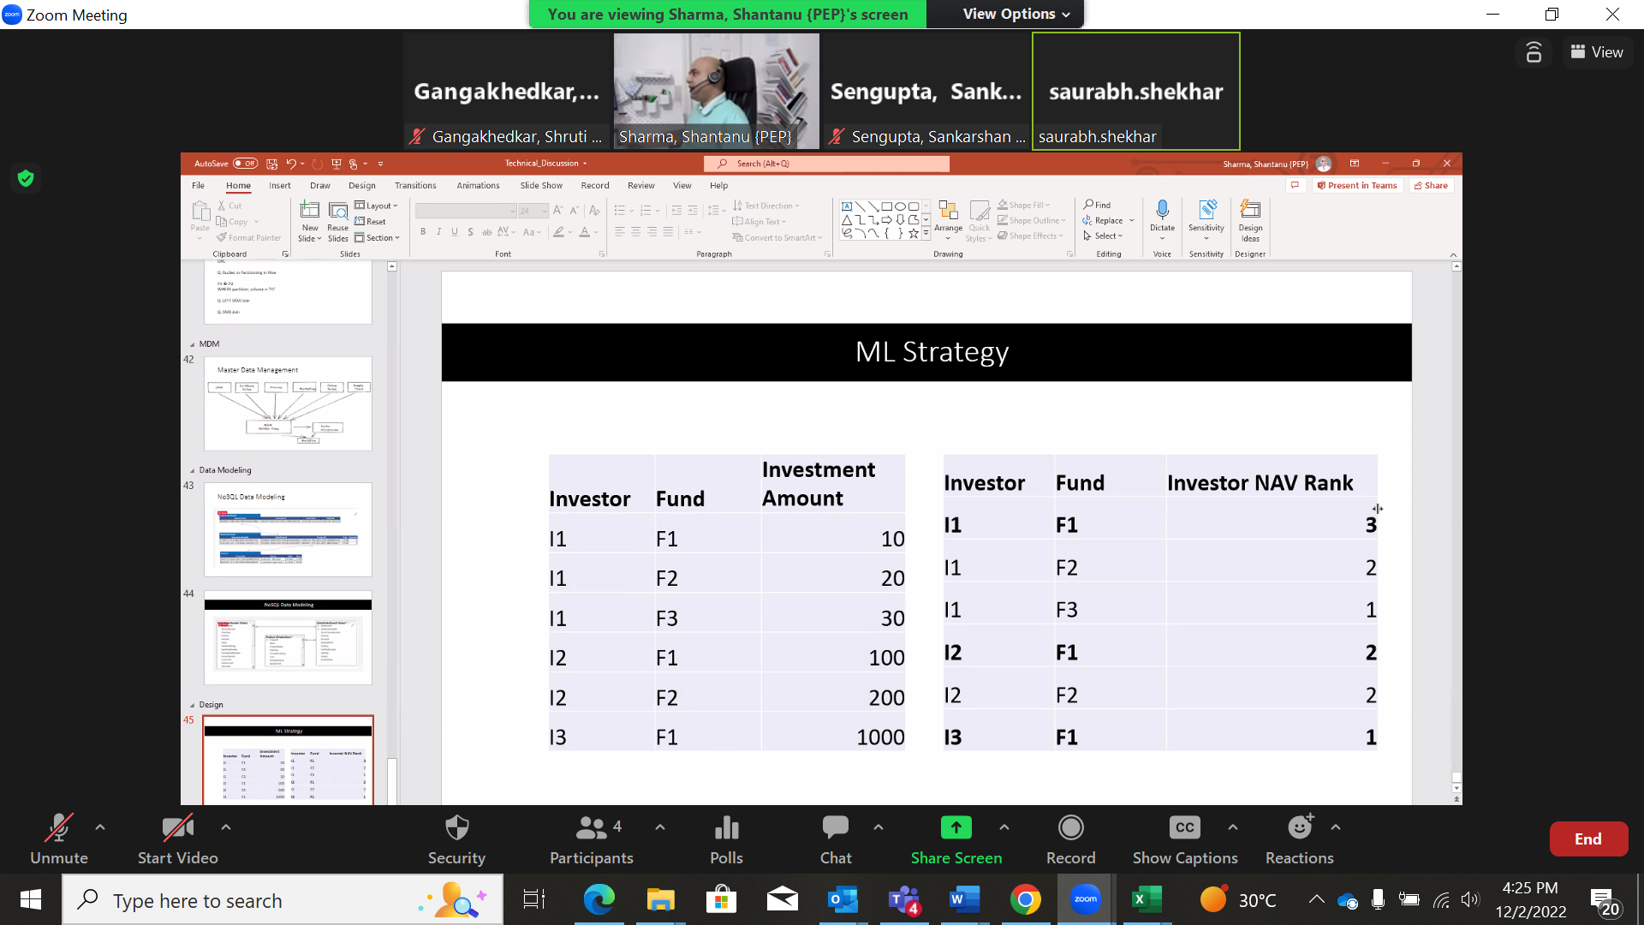

- Experience with respect to Data modeling
- 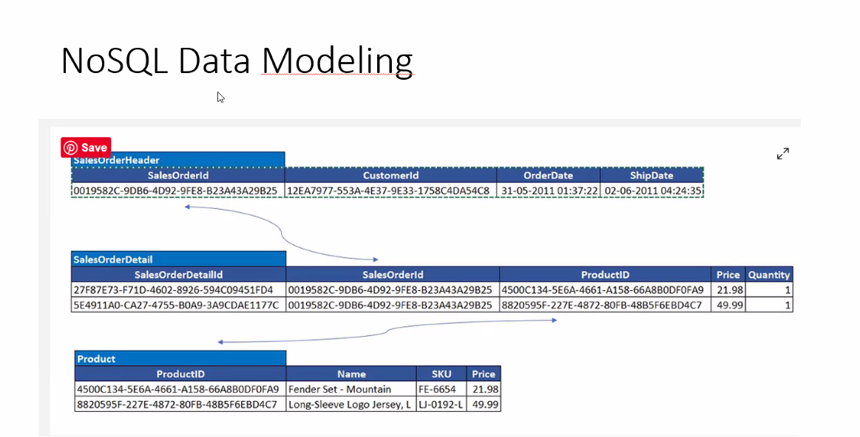

Ecommerce vendor - 3 tables
How to optimize the data model , if the data handled is huge ?
(talks on partitioning )
Follow up question -If join json format – nested column - sales orderd + customer id - nested column- how it will work

- 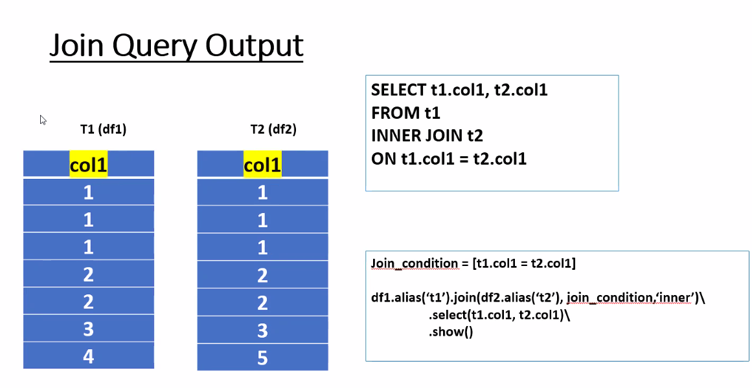
How many records in the output

- 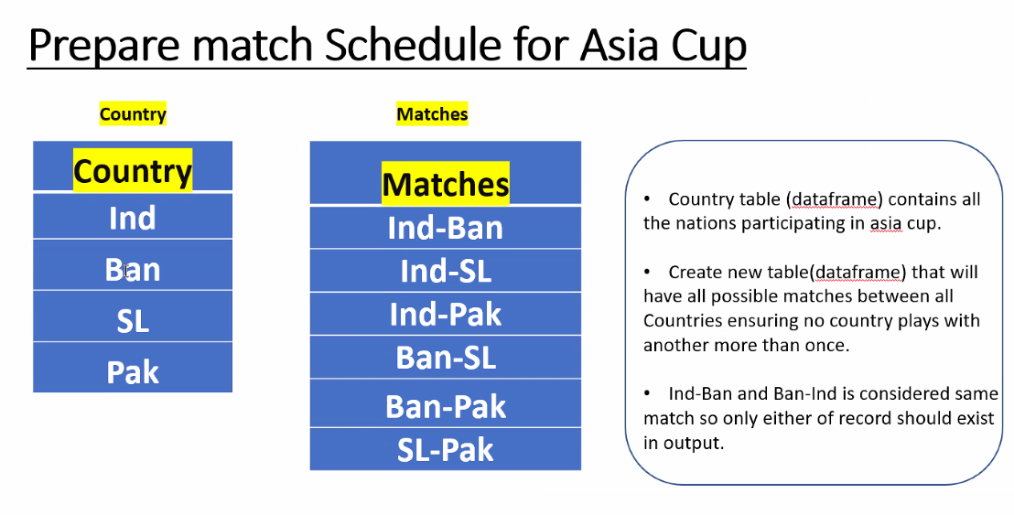
With the country list, use the conditions and get list of the matches

Using the first 3 columns - get the next 3 columns
- 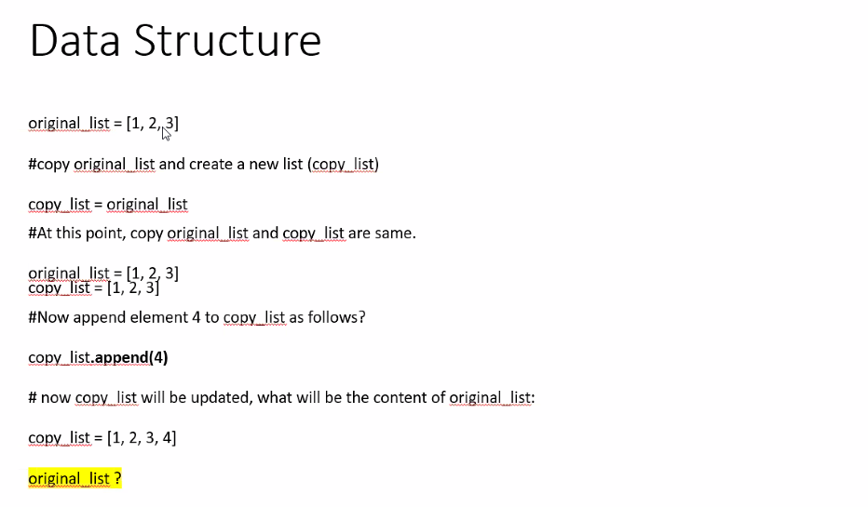
What is original list ?
Req to copy original list and make changes without impacting the original list

Storing a huge int as list as it is not storable in bigint, Need to increment the number with 1 - write a function that will handle this

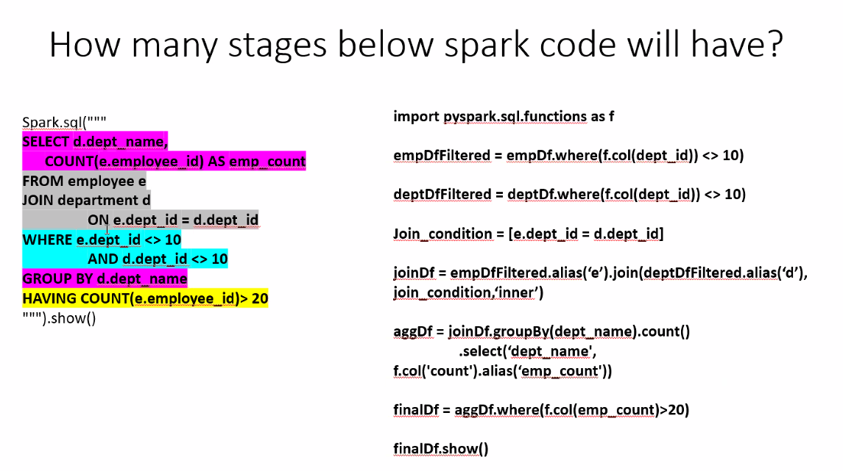

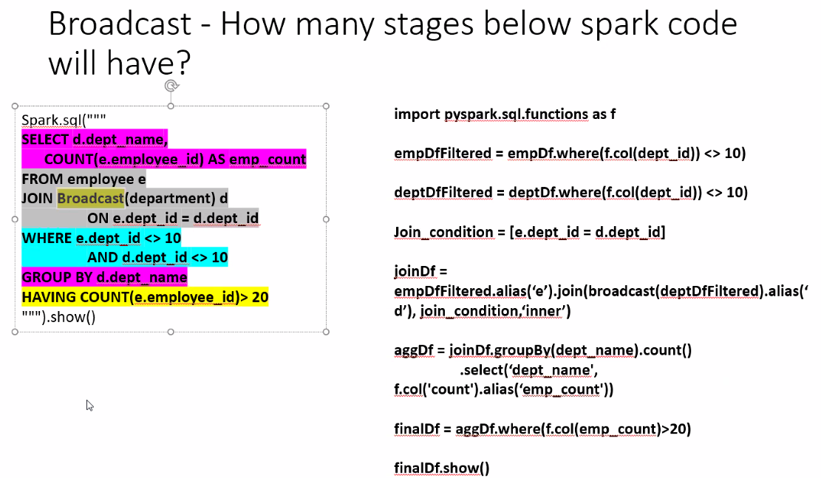

- Out of memory issue

- Slowly changing dimensions

- Degenerate dimension

- Fact less fact - Scd type 2, in fact table or different.

